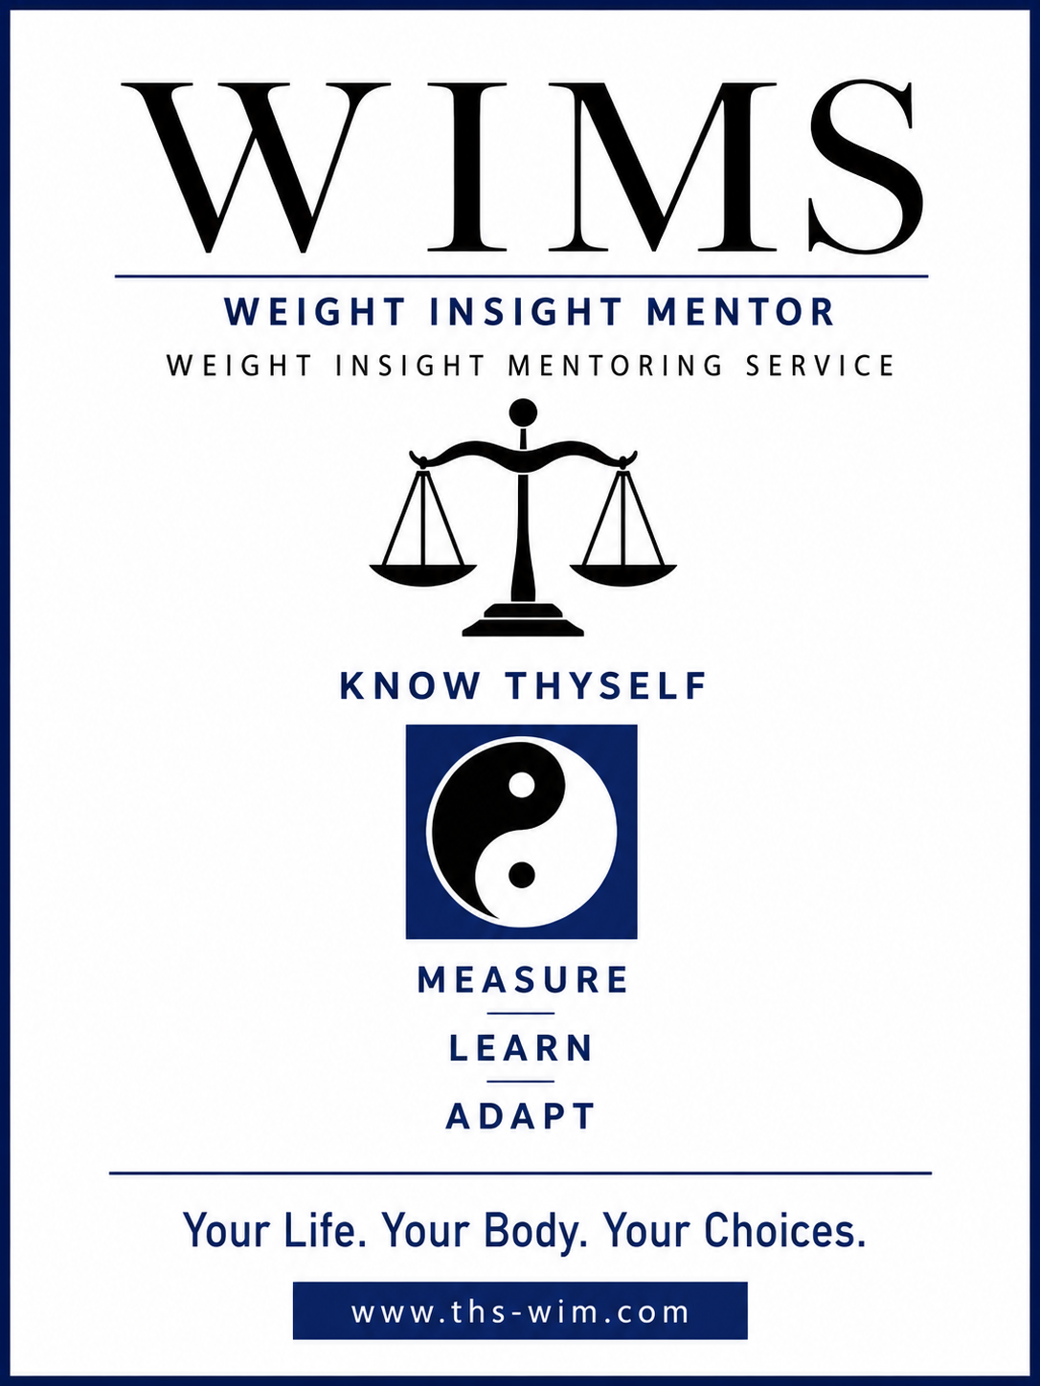

Weight Insight Mentoring Service (WIMS)

Service Definition for the Educational Platform

Know Thyself
Measure. Learn. Adapt

What is WIMS?

The Weight Insight Mentoring Service (WIMS) is an educational platform and mentoring service that helps individuals develop a better understanding of the relationship between lifestyle, human biology and weight management.

Rather than promoting a specific diet or weight-loss programme, WIMS encourages individuals to understand their own bodies through observation, measurement, learning and adaptation.

The service combines educational resources, practical tools, mentoring and ongoing research to support informed decision making. The platform includes reports, articles, presentations, videos, downloadable resources and optional one-to-one mentoring.

WIMS is intended to complement—not replace—the advice provided by qualified medical and healthcare professionals.

Vision

The long-term vision of WIMS is to become a recognised educational platform that improves public understanding of human biology, behaviour and sustainable weight management.

The platform aims to make complex scientific concepts accessible to the general public through clear educational material supported by observation, measurement and evidence-informed learning.

Over time, WIMS will continue to expand through educational publications, online resources, mentoring, community engagement and collaboration with researchers and educational organisations.

Purpose
The purpose of WIMS is to help individuals better understand themselves and make informed decisions about their health through education.
The service seeks to improve understanding of the factors influencing weight change by encouraging individuals to observe their own experiences, measure meaningful information, learn from both scientific knowledge and personal observation, and adapt their behaviour accordingly.
The purpose is not simply to help people lose weight, but to develop greater understanding, confidence and long-term autonomy.

Educational Philosophy

The educational philosophy of WIMS is based upon four guiding principles:

- Know Thyself
- Measure
- Learn
- Adapt

These principles recognise that every individual is uniquely different and that no single approach is appropriate for everyone.

Rather than prescribing a universal solution, WIMS encourages individuals to develop insight through structured observation, measurement and reflection.

Established scientific knowledge provides important context for understanding human biology; however, personal observation remains central to the learning process. WIMS therefore promotes evidence-informed education that combines current scientific understanding with carefully documented personal experience.

Know Thyself

Many people struggle with their weight. The WIMS service aims to help users develop a clearer understanding of where they are now, how they arrived there and what realistic progress looks like.

The content should be written in a relatable, accessible style rather than an academic or technical one.
Users should feel they are learning from someone who has travelled a similar path and spent years studying and experimenting with different approaches.
WIMS aims to help people develop insight, confidence and understanding of how lifestyle influences weight.

The WIMS philosophy is founded on the principle of Know Thyself. Every individual is unique. Genetics, biology, life experiences, environment, habits, family influences, and other personal factors all contribute to how each person responds to lifestyle choices.

Rather than assuming that a single approach is suitable for everyone, WIMS encourages individuals to observe themselves, measure meaningful outcomes, learn from their own experiences and adapt their behaviour accordingly.

Measure

Measurement remains central to the entire service.

The website explains why measurement matters, what should be measured, and how to record data consistently. The weight-tracking spreadsheet is the primary measuring tool within the WIMS service.

The emphasis is not on reacting to daily fluctuations but on gathering meaningful information over time so that patterns can be identified and understood.

Learn

The website is an educational platform containing articles, reports, guides, videos, and educational material.

Future content includes practical and educational topics such as blood sugar, insulin, metabolism, glycogen, fasting, energy balance, weight fluctuations, weekly averages, behaviour change, habit formation, sleep, stress, exercise, and long-term maintenance.

Each article or video helps visitors build their understanding step by step. The aim is to create a coherent body of knowledge rather than a collection of unrelated posts.

Adapt

The ultimate goal is to help and support people to make informed choices based on what they learn from the educational platform and from their own weight experiments and experience.

The framework of Know Thyself – Measure – Learn – Adapt provides a continuous improvement cycle that can be applied regardless of the specific dietary or lifestyle approach being followed.

The website, videos, spreadsheet, reports, and mentoring services all support this same process.

Over time, users may begin by reading articles and using the spreadsheet, then progress to watching videos, asking questions, and eventually seeking one-to-one mentoring support.

References

Heap, G. (2026). June 2026 fasting report: Weight management as measurement and a feedback system: A reflective, data-led personal case study (September 2025–January 2026).

Project Management Institute. (2025). A guide to the Project Management Body of Knowledge (PMBOK® Guide) (8th ed.). Project Management Institute.

Patrick Holford — Optimum Nutrition

Patrick Holford — The Low GL Diet Bible

Alan Goldhamer & Douglas Lisle — The Pleasure Trap

Alan Goldhamer — Can Fasting Save Your Life?

